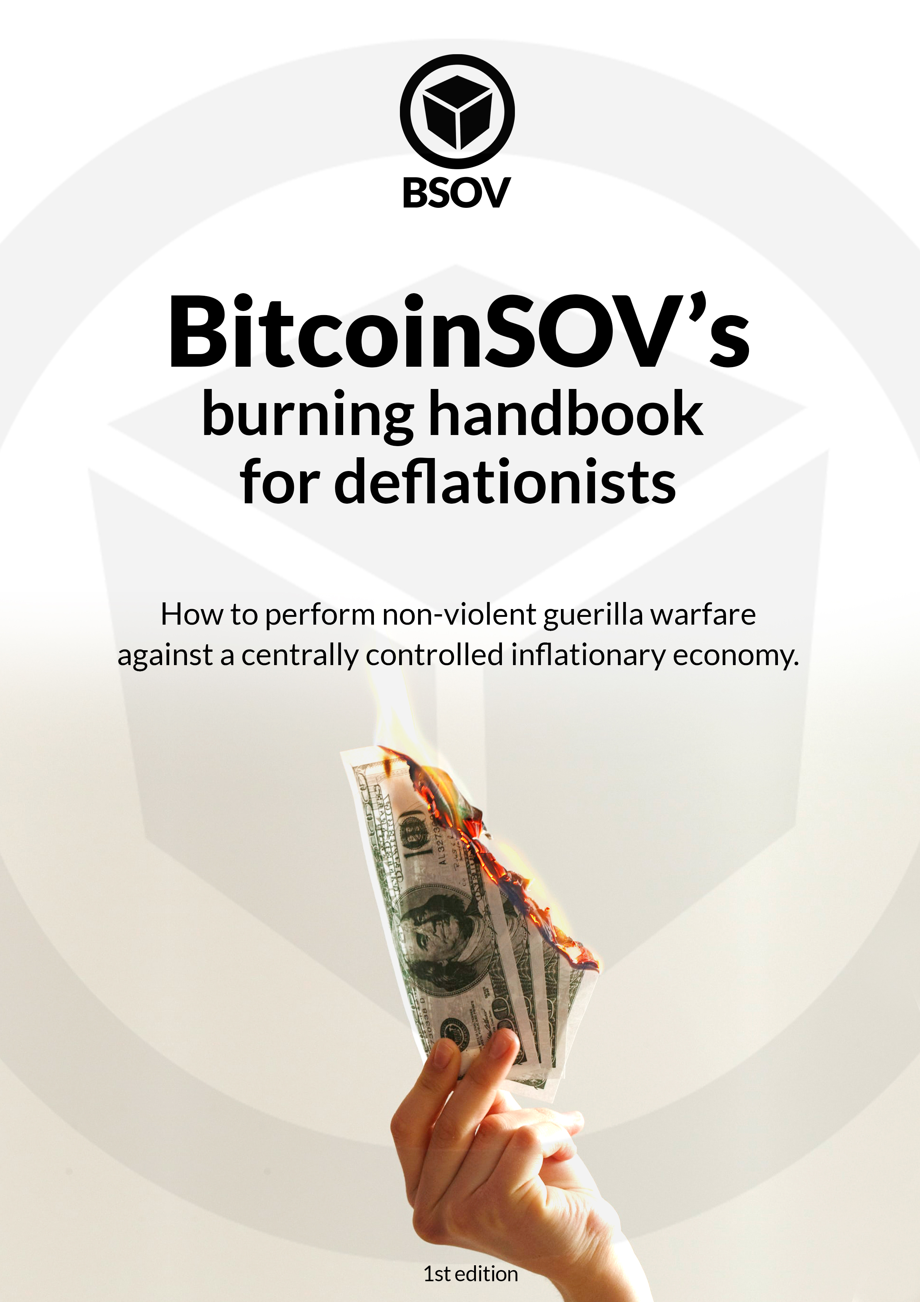
BitcoinSOV's burning handbook for non-violent deflationists – How to perform non-violent guerilla warfare against a centrally controlled inflationary economy.

Foreword by a community contributor
The current financial system which the world economy is built on, is broken. It is a system which has been utilized and manipulated for centuries, dating back to 300 B.C. While this system was intended for proper use without corruption or greed - we now live in a world where the monetary system can fail and be misused to the benefit of bad actors. More unfortunate in this situation is the misuse spearheaded by governments, militias, and the 1% of those holding the wealth.
Inflation has pierced the hearts and wallets of billions of people. The Venezuelan Bolivar is a prime example of the single-point-of-failure problem which the current centralized monetary system is facilitating. Food, utilities and household items which were once affordable are now hot commodities and considered a sign of wealth.
Inflation is the outcome from the wrongdoings of those in power, and lower monetary value is the crippling and debilitating result. How did this begin? What is the solution? Is the end of inflation in sight? These are all questions which desperately need answers, and there is hope.
While BitcoinSoV (BSOV) is not a proven solution and should be considered experimental in nature, there are calculations which show that the project can succeed if enough adoption occurs. BSOV tries to solve the issue of inflation and disinflation with a self destructive supply - The deflationary mechanism (1% of every transaction is burned and destroyed). The code of BSOV is immutable and proves extremely difficult to change.
We pay taxes to our countries who in turn misappropriate those funds whilst shrouding what exactly these funds are being allocated for. With a blockchain holding every transaction and movement of the commodity in a database, transparency would no longer be an issue.
While BSOV's mission and purpose is an extremely ambitious one, something must be done to help people of all creeds and culture. All of us deserve more. BSOV plans on doing just that, no matter who the opposition is.
"We cannot solve our problems with the same level of thinking that created them." - Albert Einstein.

Table of Contents
Introduction
What is this?...............................................................................................................1
Ideology .......................................................................................................................2
Methods of non-violent action............................................................................3
Swarmwise - the tactical manual to changing the world …......................4
Join the Swarm - and the first task …................................................................5
Taking action
Burning fiat-money as a symbol ….....................................................................6
Create art for change..............................................................................................7
Printable Stencil........................................................................................................8
Print this book, give this book, edit this book, upload this book ….......9
Organize your local swarm group ..................................................................10
Computer nerds - Technical contributions ….............................................11
Be generous.............................................................................................................12
Because two deflationists are better than one deflationist.................13
Financial Freedom & Commitment
Timelocking with SovCube................................................................................14
Donations to the First BitcoinSOV Foundation (BSOV-F1) ….............15
Mining BSOV...........................................................................................................16
Useful info, links & literature.............................................................................17

What is this?

What is the BitcoinSOV’s deflationary currency movement?
The BitcoinSOV community is calling all enthusiasts of cryptocurrencies together, to protest against the creators of Centrally Controlled Inflationary Currencies (CCIC).

What is a Centrally Controlled Inflationary Currency (CCIC)?
CCIC’s are usually government-made fiat-currencies like $USD, €EUR, or the worst examples: The Venezuelan Bolívar (VEF). All the world’s central banks and governments control the inflation of fiat. As citizens of any nation state, we are currently forced or limited to use these fiat-currencies as a Medium of Exchange (MoE).

What is BitcoinSOV (BSOV)?
BitcoinSOV is a cryptocurrency which is mineable by work, committed by community and deflationary by design. The biggest differentiatior of BSOV, is the deflationary mechanism of 1% transaction burn. Also, the BitcoinSOV community differentiate themselves by being committed to holding the token.

What is a deflationist?
A deflationist is a person who is an advocate for deflation. In this context, a deflationist is an advocate for cryptocurrencies like Bitcoin (BTC) or the “deflationary by design” BitcoinSOV (BSOV).
But... What is this book?
This is a handbook for non-violent deflationists - A guide to make the mainstream community start debating about the very fundamental existence of our old monetary system. This handbook is made to encourage the people to start to care about financial freedom, and freedom from inflation manipulated by centralized powers.
This is BitcoinSOV - Store-of-Value.

Ideology
Cryptocurrency adoption will not happen without an army of committed people who are not afraid to tell their friends and family about the new liberated economy - called Cryptocurrency.
BitcoinSOV defends the right for people to protect themselves from inflation and government-made currencies.

BitcoinSOV fights for:
- Freedom from inflation.
- Financial independence and freedom from government-made regulation.
- Monetary alternatives which are deflationary by design.
- Usage of sound money and decentralized cryptocurrencies.

Goals
BitcoinSOV has a long-term plan to create real impact to the world.

BitcoinSOV wishes to achieve:
- A mainstream debate about cryptocurrencies.
- A shift in the mainstream understanding of cryptocurrencies.
- A mainstream consideration of BSOV and its deflationary mechanism.
- A mainstream usage of BSOV as a Store-of-Value (SoV).

Methods of non-violent action

Don’t become an asshole.
Non-violence could be a very effective method to avoid being interpreted as a dangerous sociopath, so why not make the best impression on people? Even if we scream and shout, and walk the streets with signs to advocate for financial freedom - We need to respect other people’s freedom too. We should not be hypocrites and assholes - rather be polite.

Peaceful protest by boycotting products, and using alternatives.
The US Dollar is a government-made and centrally controlled product. Bitcoin is relatively decentralized, and its inflation-rate is predictable and immutable. One of the most peaceful ways the world’s population could dissent non-ethical products, is by using alternatives. The alternative is cryptocurrency in general - Those cryptocurrencies which hold and attain value are better suited.

Examples of non-violent action
- Public speeches
- Slogans, caricatures, and symbols
- Banners, posters, and displayed communications
- Declarations by organizations and institutions
- Group or mass petitions
- Displays of flags and symbolic colors
- Paint as protest
- Symbolic sounds
- Singing
- Marches
- Parades
- Protest meetings
- Assemblies of protest or support
- Silence

Inspiration:
The non-violent aspect of this book was inspired by “198 Methods of Nonviolent Action” [1] by the “Albert Einstein Institution”.

Swarmwise

The tactical manual to changing the World
Swarmwise [2] is a publicly available and free book written by Rick Falkvinge, the founder of the politial Swedish pirate party. I recommend reading it - since this text only provides a short summary.

What is a Swarm?
A swarm is a horde of people who follow and do actions towards great ideas.

Organizing a leaderless movement.
A swarm doesn’t consist of leaders who has authority. The swarm is autonomous and the individials have tasks more like janitors - or bees.
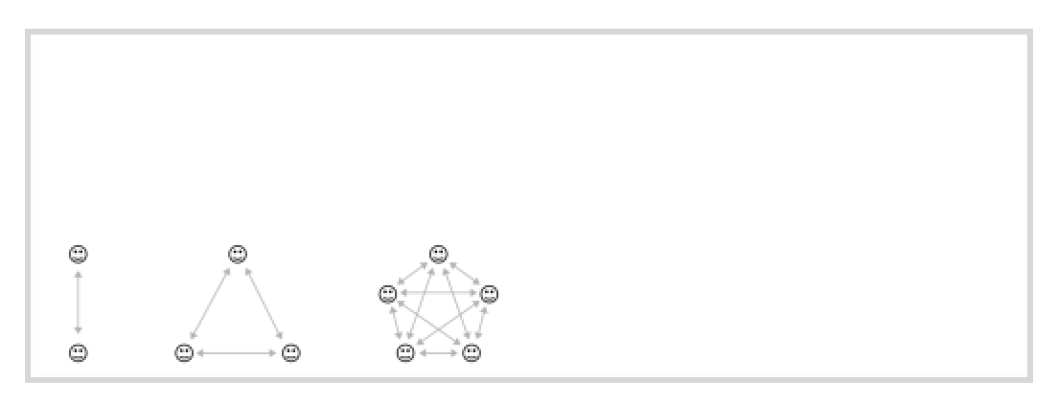

The organization consists only of relationships between people.
For this reason alone - The smallest swarm-groups work more efficiently than the bigger swarm-groups. If the group is small, the less work the whole group has to do to maintain all the relationships in order to function as a working group. for example (7 people = 21 relationships), which is a lot.

No one can tell you what to do .
A swarm is not a democracy or a dictatorship. Nobody gets to tell anybody else what to do. This is the norm for a swarm. Some people call it a “do-ocracy.”

Mistakes are allowed - and they are expected.
The inevitable outcome of a swarm is sporadic chaos and disorganization. This is allowed, and doesn’t need to be fixed by organizational astronauts.

Respect anonymity
The identity of the individuals of the swarm are to be protected if they wish to keep themselves hidden.
If you’re not making somebody angry, you’re probably not doing anything useful.

Join the Swarm - and the first task
The purpose of the first task is to kickstart the Swarm and, after this, the Swarm creates new tasks by itself.
First Task:

Reach 100.000 signatures to the petition at Change.org
Petition name: "Stop the government's monopoly of currency.”
(You can find the link at https://btcsov.com/deflationist ).

Petition Text:

BitcoinSOV (BSOV) started this petition to all governments os the world.
In reaction to the hyper-inflation crisis in Venezuela, there has been created a cryptocurrency which is deflationary by design - It is called BitcoinSOV (BSOV), and it is asking for the world to care about personal sovereignty - Also known as – The freedom to rule over your self.
The world's population should claim the right to have financial independence, and freedom from Centrally Controlled Inflationary Currencies (CCIC).
The governments should not force the usage of their fiat-currencies, and they should not regulate the usage of other decentralized cryptocurrencies like BitcoinSOV (BSOV).
The community of BitcoinSOV (BSOV) is claiming independence from the old financial system, and are now collecting signatures from cryptocurrency enthusiasts, or from people who care about a future where they don't need to trust a government to be able to own money - A future where the people aren't forced with violence or prison to use fiat-currencies for governmental fees.
The financial future is decentralized and trustless with the help of blockchain technology that makes every transaction of BitcoinSOV secure. Be a part of a future which is committed by the community and decentralized by design.

Burning fiat-money as a symbol.
In some places it is illegal to burn fiat-money, even if the money is supposed to be a part of your individual property. Do citizens not have freedom over their own hard-earned money?
- Take charge over your own money.
- Show the world what deflation really means.
- Remember: You are a deflationist.
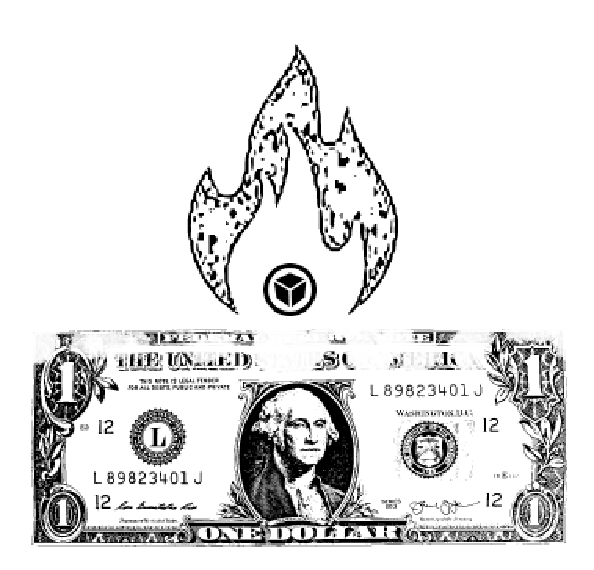
- Share the idea.

Create art for change
Decorate your floors and walls with BSOV stencil art. (See the next page) Art inspires our imagination and is a very powerful tool for communication. Symbols are an important part of an ideological revolution, and you are free to practice this tool in any non-violent way.
You can design, paint, write, sing, draw, sculpt, spray, perform, dance - Only the fantasy sets limits.
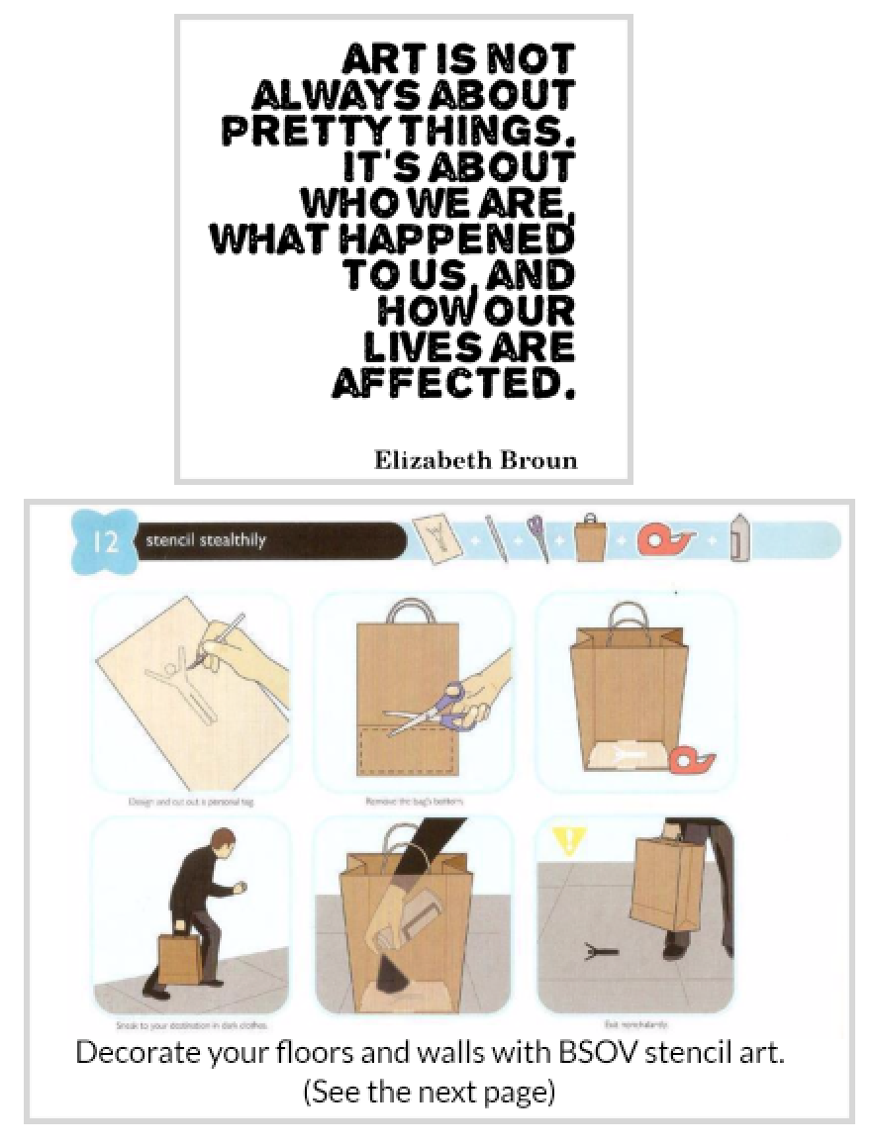
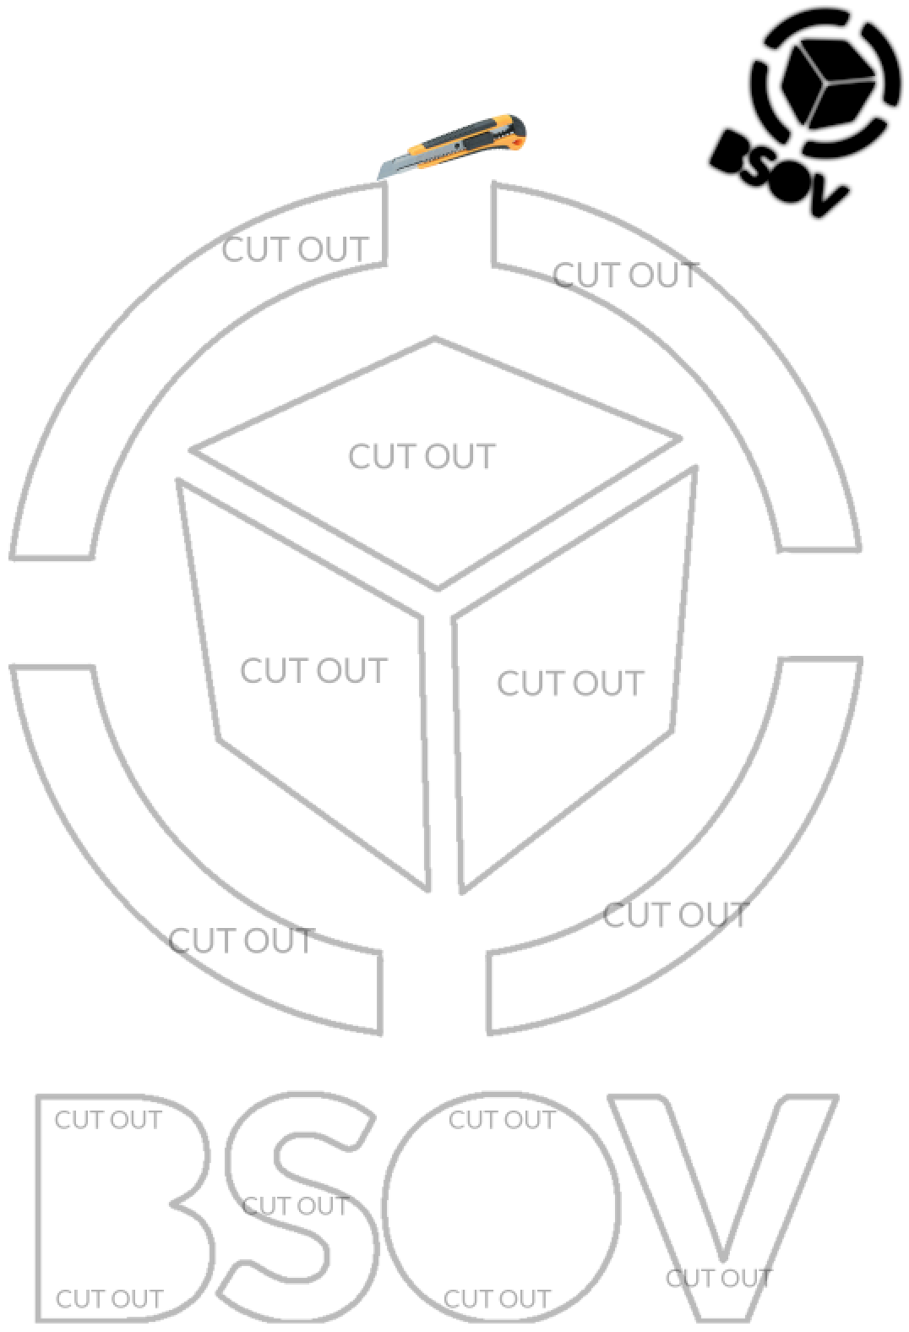
Use an utility knife to cut out these shapes.
Hint: Cardboard is more durable than paper.

Print this book, give this book,

edit this book, upload this book

Print this book
This 1st edition of the book deserves to be printed on real paper, and our movement deserves many copies worldwide.

Give away this book
First give the book to your closest friends who already are into cryptocurrencies, then after them, the real challenge is to make “no-cryptoers” care about financial freedom. There is no need to waste good paper on someone who will throw away this book.

Edit this book
You will find all the source-files for this 1st edition at btcsov.com - So please translate this 1st edition into your local language, or if you feel confident enough to start writing a 2nd edition, then feel free to copy and edit any image and text in this book.

Upload this book
You are free to upload this book wherever you may see fit. Torrent sites like ThePirateBay, LBRY, Youtube, Instagram, Twitter, Facebook... the list goes on.
- Please do share it.

Organize your local swarm group
Now, you remember we talked about the Swarm in page 4? It could be wise to read the page again, or even start reading the full book by Rick Falkvinge. This page is mostly for those who have an entrepreneural spirit, and who are great at communicating. Remember, your group may last a long time, so you are better off putting a lot of dedication and thought into it.

1. Gather your geographic swarm on the internet.
Go to btcsov.com and enter one of the chats and ask if there is already a group for your country. If not - then make one and tell everyone in the chats.

2. Gather your local friend swarm in your local area.
You and your friends who live close to you, are the most powerful people in a swarm. These swarm-members are nearly the only ones who are able to physically be present in your non-violent endeavors - And these swarm-members are the only ones you can physically join, if they end up having good, effective or provocative ideas.

3. Remember: The smaller, the more efficient.
The most optimal local swarm group sizes are 1-7. If your local swarm group becomes over 150, then you are better off creating a new one, or you can suggest splitting into smaller groups.

4. Develop strategies - be experimental.
There are no wrong questions and no right answers. We only strive towards what we believe - This is why you don’t need a leader. You are under self-rule.

5. Do non-violent action out on the street, together.
The more you can get away from your computer, the more real-world impact you can make.

Computer nerds – Technical contributions
There are many ways to contribute technically.

- Go to the online chats at https://btcsov.com/chat and ask if you can help.
- Create mirrors of the https://btcsov.com website.
- Create mining pools.
- Create and maintain statistics bots in Twitter, Discord, Telegram.
- Help develop https://btcsov.com and https://sovcube.com
- Develop an easy way to generate bulk of printable paper wallets.
- Develop plugins for FPGA mining units.
- New ideas are welcome too.

Be generous

Don’t be like Ebenezer Scrooge from “A Christmas Carol”
No one likes a greedy and grumpy bore. Since the swarm is based entirely on relationships and social interactions, then the hive will be benefit from a culture of sharing and generosity.

Give your friends & family some BSOV.
Either give them a private key/mnemonic seed with some BSOV, or even better – Teach them how to create a wallet, send them BSOV, and then teach them how to timelock the BSOV, (timelocking is explained later in this book, at page 14). Why not make wallets for your children and put BSOV in them, and timelock until the day they become 25. Cryptocurrency is for the future – and so are our children.

Give your online friends some BSOV.
Send BSOV to your online friends, or people you talk with online. Give them links to btcsov.com to teach them about the revolution.

Reward Swarm-members for helpful contributions
The easiest way to get strangers involved, would be to give them BSOV paper wallet as an incentive and a link to btcsov.com, where we could educate them about cryptocurrency.

Donate to the BitcoinSOV Foundation
You can find more info at https://btcsov.com/growth

Because two deflationists

are better than one deflationist

All cryptocurrency enthusiasts need to unify and go head-on to the future of financial freedom.
This pledge is made of those enthusiasts who would like to promise to yourself or to the hive – That you are committed to our cause and to !the first task”.

Caring for yourself and others; and the hive and queen.
The deflationist cares abouthimself/herself or their closest friends and family, but they do care a lot about the swarm hive and the queen.

The Swarm Hive
The swarm hives are the chats and social medias provided at https://btcsov.com/chat and more of them can be created by YOU.

The Queen
In the hive we have our queen – and she must be protected. Our queen is our ideology and belief in a future with financial freedom.

Symbol of dedication.
Your majesty. Queen of BitcoinSOV.
I hereby dedicate myself to financial freedom and freedom from inflation.

Signature (name or pseudonym) Date & place

____________________________ ________________________

Timelocking with SovCube

SovCube is BitcoinSOV’s best friend.
The SovCube.com website provides a smart-contract to timelock your tokens and it also measures something called Proof-of-commitment.

Store your tokens for the future with SovCube.
You and anyone can contribute to the total token holder integrity of BSOV, and prove your commitment to the vision on BitcoinSOV.

BitcoinSOV (BSOV) has a high Proof-of-Commitment
Proof-of-Commitment tries to quantify the total amount of commitment which token holders have for a cryptocurrency project, and can be reoresented with this equation:

% of circulating tokens locked * amount of time locked = Proof-of-Commitment

Over 25% of circulating BSOV is already timelocked by volunteers without any incentives – Actually, ~2% of the timelocked BSOV are destroyed before you get them back.

Read more about SovCube at https://btcsov.com/sovcube or https://SovCube.com

Donations to the First BitcoinSOV Foundation (BSOV-F1)

0 percent of BSOV were distributed to the creator of BSOV.
So the full responsibility lies on the community to fund its operations.

BitcoinSOV is 100% community-driven.
And does not rely on centralized decision makers or traditional power structures to survive. This deflationary grassroots movement is built from the bottom-up, and is fully reliant on people like you to build it.

BSOV-F1. The first foundation of many to come.
The current community has agreed to create a multisignature donation wallet, and to eventually establish an NGO which we can call something like First BitcoinSOV Foundation (BSOV-F1).

One day someone may create a Second BitcoinSOV Foundation (BSOV-F2).
I don’t know if you like the name, but I think this would be a logical way to sort them chronologically. I don’t know.

DON’T LET ANYONE TELL YOU WHAT TO DO

Read about growth at https://btcsov.com/growth

Mining BSOV

The only way to create BSOV tokens is to mine it.
Due to the design of BitcoinSOV, the only way to generate new tokens is by using computers or hardware to mine it. You can also receive BSOV from someone else, or even buy it from a cryptocurrency exchange.

Earn BSOV by mining
You may earn BSOV and end up with profit if you get the right mining equipment. The competition may be relentless, so it is advised that you do your research first. If you are an opportunist, and you already have some technical skills, then mining is a very good way to contribute to BitcoinSOV and earn money.

BSOV is worth money - Because it is money
BSOV is traded on cryptocurrency exchanges, and has a market price. Due BS to supply and demand and free market mechanics, the price is currently highly variable.

You are coming early to the show.
At the time of writing, only 13% of the max supply of BitcoinSOV has been mined. The first ~10 years of mining will be the most profitable years, since the reward will be subject to “halvings” about every 4th year, just like Bitcoin. Now the reward is 50 BSOV per solved hash, and in some years it will be halved to 25 BSOV.

Mining is a competition between many actors
The more power which is mining BSOV, the more difficult and expensive it will be to mine. This design may provide a healthy competition between people, and hardware-producers may start to commercialize and compete for specific hardware-production as well.

Start mining now, visit: https://btcsov.com/mining

Useful info
Good luck, fellow Swarm member. Now go to our community and tell them you've read this book, and start completing the first task from page 5.

Website: btcsov.com

For non-violent deflationists: https://btcsov.com/deflationist

Telegram Community chat: https://t.me/BitcoinSoVCommunity

Literature:
[1]
“198 Methods of Nonviolent Action [PDF]” by the “Albert Einstein Institution – advancing freedom with nonviolent action”
[2]
“Swarmwise – The tactical manual to changing the world.”[PDF] written by Rick Falkvinge, the founder of the Swedish Pirate Party

